**PODAR INTERNATIONAL SCHOOL,**

**GANDHINAGAR**



Practical File

Session -2023-24

Subject Code: 402



Name: ________________________ Submitted to :

Class: _________________________ Mr. Gaurav Upadhyay

Rollno:________________________ (Internal Examiner)

**CERTIFICATE**

THIS IS TO CERTIFY THAT ________________________ OF CLASS 10 HAS SUCCESSFULLY COMPLETED THE PRACTICAL WORK ON IT(402) FOR CLASS X PRACTICAL EXAMINATION  AS PRESCRIBED BY MR. GAURAV UPADHYAY (INTERNAL EXAMINER), DURING THE ACADEMIC YEAR 2023-2024 AS PER THE GUIDELINES ISSUES BY CENTRAL BOARD OF SECONDARY EDUCATION - CBSE.

Signature:

Date :

**INDEX**

| **Sr.No** | **Topic** | **Signature** |
| --- | --- | --- |
|  |  |  |
|  |  |  |
|  |  |  |
|  |  |  |
|  |  |  |
|  |  |  |
|  |  |  |
|  |  |  |
|  |  |  |
|  |  |  |
|  |  |  |
|  |  |  |
|  |  |  |
|  |  |  |
|  |  |  |
|  |  |  |
|  |  |  |
|  |  |  |
|  |  |  |
|  |  |  |
|  |  |  |

## PODAR INTERNATIONAL SCHOOL, GANDHINAGAR

## Class X Practical File ::Information Technology (402) ::Session 2023-24

**Instructions:**

1. **Front page displaying all your details along with subject code and teacher Incharge.**
2. **Index along with Sequence numbers and Teachers signature.**
3. **Screenshots are required.**

**Software Requirement : Open Office (OO Writer, OO Calc, OO Base)**

**Open Office Writer**

## Assignment 1:

**Objective:**Insert image into document and format the contents

**Task:**Type the following paragraph in OO Writer and follow the given instructions:

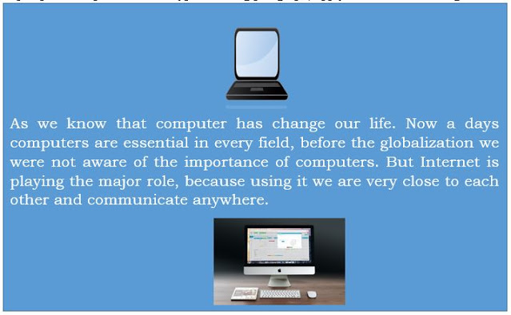

**Instructions:**

1. Insert a computer picture from Gallery on top of the paragraph.
2. Search a computer picture from Google and download in your computer and insert in the document.
3. Resize the picture as it fits in your document.
4. Crop image 2 and remove unwanted part.

## Assignment 2:

**Objective:**Creating drawing objects

**Task:**Create different drawing objects from the drawing objects gallery.

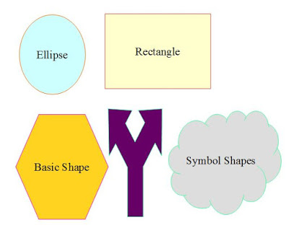

## Assignment 3:

**Objective:**Changing the template from default to custom

**Task:**Open OO writer and change the default template to custom template using the following formatting:

* Font: Verdana, Font Size: 14 pt, Font colour: Automatic
* Main Headings in the template: Font – Verdana, Size – 24 pt, Font colour – Blue
* Heading level 2: Font – Verdana, Size – 20 pt, Font colour – Maroon
* Heading level 3: Font – Verdana, Size – 18 pt, Font colour – Red

Now write a complete article on Generation of Computers and save it. Use the above formatting for different contents of the document.

## Assignment 4:

**Objective:**Selecting columns and applying to format

**Task:**Apply different background colours to rows and columns (Use colours of your choice)

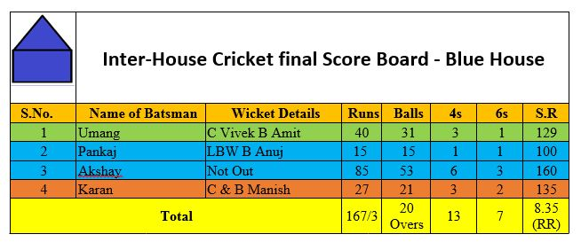

**Task:**

* Insert a row above the first row and merge all cells and write heading: **Inter-House Cricket final Score Board – Blue House.**
* **Insert an image in front of heading and split merged cells into two columns and one row**
* **Align the text and image properly**
* Insert a row below the second row and insert data: 3, Akashay, Not Out, 85, 53, 6, 3
* Delete a row 5 having data of Nirbhay
* Insert columns after 6s column and give the heading strike rate and calculate the strike rate manually and write it accordingly
* Insert row below the last row for a total

## Assignment 5:

**Objective:**Updating the table of contents.

**Task:**Add a part of the questions and answers in the previously typed chapter. Apply proper

headings like objective type questions, Descriptive Questions, Short answers questions etc. Update

the table of contents.

**Open Office CALC**

## **Assignment 6 - Using consolidating data**

**Prepare worksheet as given below and do as directed:**

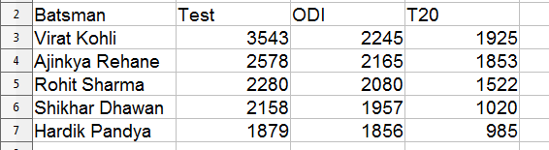

Data for Define Range

1. Assume these data is for previous year. Now add one more worksheet and enter data as per your wish for all batsmen.
2. Now add one more worksheet to show the sum of these two years runs the newly added worksheet.
3. Now create ranges for your data, Give the names as Y2018 and Y2019 respectively.
4. Perform data consolidation and update data also and see the changes are reflected or not.

## **Assignment 7 - Using consolidating data**

**Prepare worksheet as given below and do as directed:**

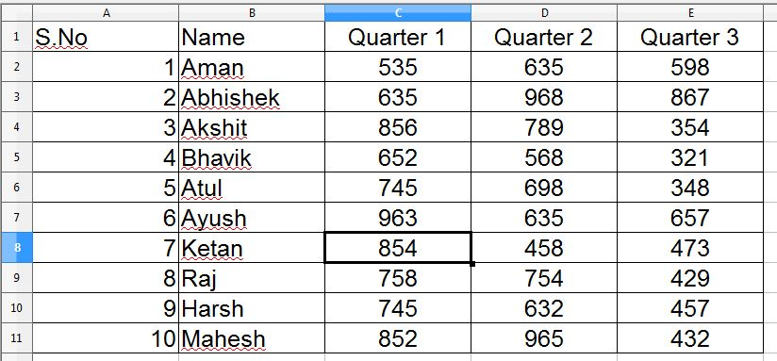

Data for Consolidation

1. Add two worksheets in the file and modify the data for all 4 quarters.
2. Rename all worksheets like sheet1 – 2018, sheet2 – 2019 and sheet3 – 2020.
3. Now add one more worksheet at the end and rename as consolidated sheet.
4. Now type the serial no and names as displayed, use sum function to add data for 2018, 2019 and 2020 in respective cells using consolidation.

## **Assignment 8 - Creating Subtotals**

**Prepare following worksheet and display the sum of item according to items and then regions.**

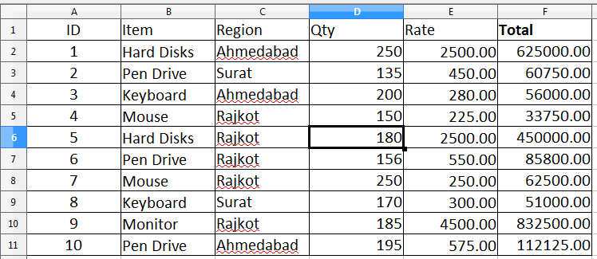

**Data for Subtotal**

Your output should be like this:

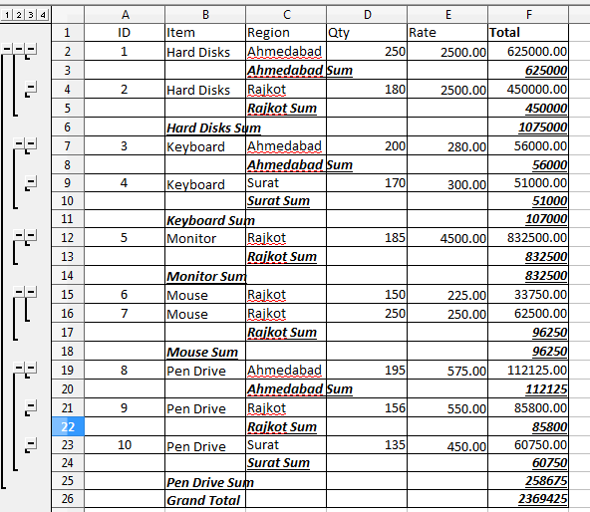

## **Assignment 9 - What-if Scenarios**

**Enter following data into worksheet and compute strike rate of batsman:**

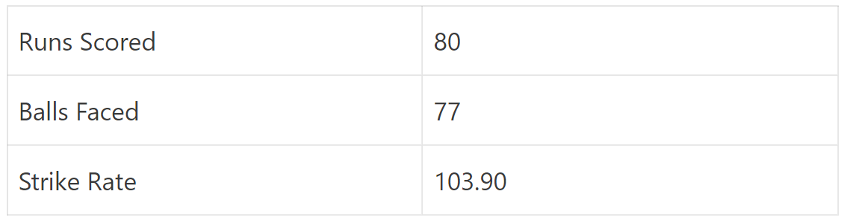

The formula for strike rate is: **=(cell1 / cell2) * 100**

Now find out the strike rate for following data and give them proper names and comments.

1. When score is 55 and balls faced are 40.
2. When score is 78 and balls faced are 80.
3. When score is 95 and balls faced are 77.

## **Assignment 10 - What-if Scenarios (Multiple Operation)**

Use the similar data as above and display the results for 5 values row wise and column wise for

each. Consider the following output:

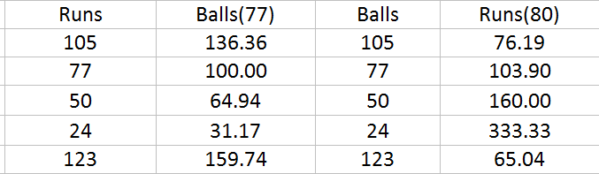

Column Wise multiple operations

Now enter same data into rows and prepared data accordingly.

**Open Office BASE - RDBMS**

## **Assignment 11**

Create following table in OO base for Database Management System 10.

**Table Name :- Students**

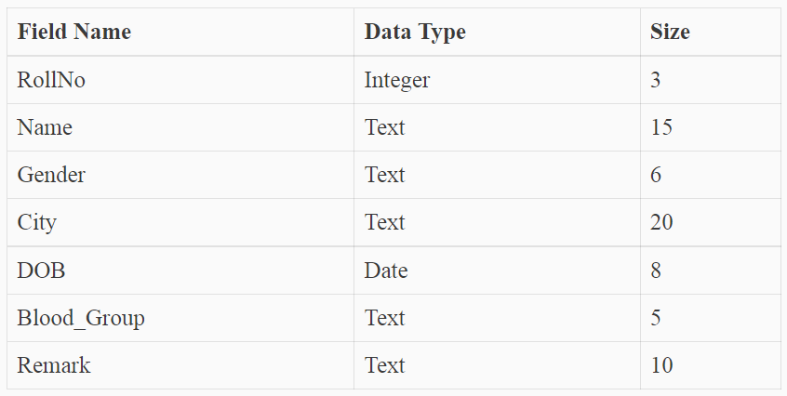

Assign **RollNo** as primary key.

## **Assignment 12**

Create a table with name Employees and write queries to design and enter the relevant details of

employees of an organization. (any 5 employees). Assign **EmpNo** as primary key

1. Name of the employee
2. Employee_Id
3. Date_of_joining
4. Posting
5. Department
6. Basic_Salary
7. Display all department data
8. Display different cities in the manager table
9. Arrange all the records in ascending order Basic_Salary wise.
10. Sort the data based on basic salary in the ascending order.

## **Assignment 13**

Create and write queries based on the following table Name Manager:

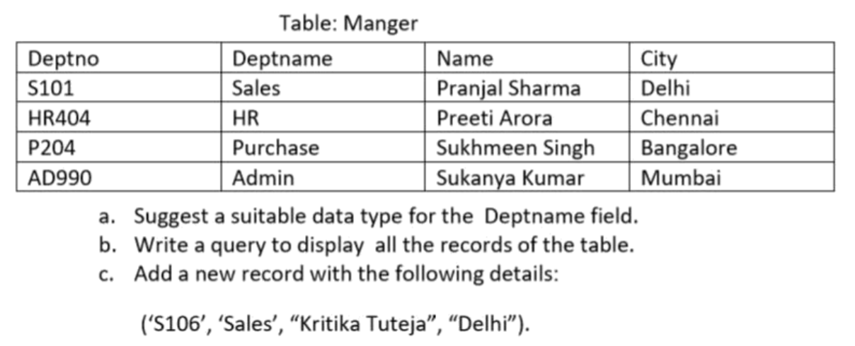

d. Display department name where city is Chennai

e. Display different cities in the manager table

f. Arrange all the records in ascending order department wise.

g. Change the Deptname HR to Admin HR.

## **Assignment 14 – Create Forms**

## 

1. Create forms by selecting all the fields for the tables – Students, Employee
2. Add 3 new records into Students table using navigation toolbar.
3. Change the label backgrounds and fonts formatting as per your choice.
4. Search records by from form of students for the boys.

## **Assignment 15 – Create Report**

Create report for the all the tables. Use your own choice of layouts. Save your reports with your

title. Write steps to complete these tasks. Attach the appropriate screenshots with that.